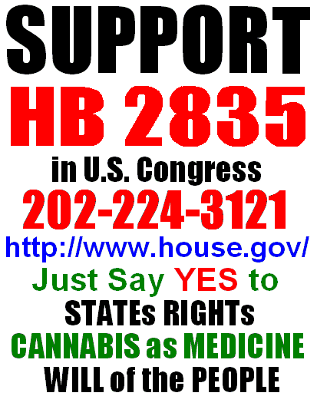
ACT NOW! Support The Medical Marijuana Patient Protection Act of 2009  Massachusetts Democrat Barney Frank, along with a bipartisan coalition of 13 co-sponsors, is seeking to strengthen legal protections for state-authorized medical marijuana patients. House Bill 2835, The Medical Marijuana Patient Protection Act of 2009, would ensure that medical cannabis patients in states that have approved its use will no longer have to fear arrest or prosecution from federal law enforcement agencies. Thirteen states -- Alaska, California, Colorado, Hawaii, Maine, Michigan, Montana, New Mexico, Nevada, Oregon, Rhode Island, Vermont and Washington -- have enacted laws protecting medical marijuana patients from state prosecution. Yet in all of these states, patients and providers still face the risk of federal sanction -- even when their actions are fully compliant with state law.  It is time that we allowed our unique federalist system to work the way it was intended. Patients and their state representatives should have the authority to enact laws permitting the medical use of cannabis -- free from federal interference. Please call, write or visit your members of Congress today and tell them to stop targeting and prosecuting medical marijuana patients and providers. For more info and on-line tools, visit –  www.W-V-NORML.org | ACT NOW! Support The Medical Marijuana Patient Protection Act of 2009  Massachusetts Democrat Barney Frank, along with a bipartisan coalition of 13 co-sponsors, is seeking to strengthen legal protections for state-authorized medical marijuana patients. House Bill 2835, The Medical Marijuana Patient Protection Act of 2009, would ensure that medical cannabis patients in states that have approved its use will no longer have to fear arrest or prosecution from federal law enforcement agencies. Thirteen states -- Alaska, California, Colorado, Hawaii, Maine, Michigan, Montana, New Mexico, Nevada, Oregon, Rhode Island, Vermont and Washington -- have enacted laws protecting medical marijuana patients from state prosecution. Yet in all of these states, patients and providers still face the risk of federal sanction -- even when their actions are fully compliant with state law.  It is time that we allowed our unique federalist system to work the way it was intended. Patients and their state representatives should have the authority to enact laws permitting the medical use of cannabis -- free from federal interference. Please call, write or visit your members of Congress today and tell them to stop targeting and prosecuting medical marijuana patients and providers. For more info and on-line tools, visit –  www.W-V-NORML.org
ACT NOW! Support The Medical Marijuana Patient Protection Act of 2009  Massachusetts Democrat Barney Frank, along with a bipartisan coalition of 13 co-sponsors, is seeking to strengthen legal protections for state-authorized medical marijuana patients. House Bill 2835, The Medical Marijuana Patient Protection Act of 2009, would ensure that medical cannabis patients in states that have approved its use will no longer have to fear arrest or prosecution from federal law enforcement agencies. Thirteen states -- Alaska, California, Colorado, Hawaii, Maine, Michigan, Montana, New Mexico, Nevada, Oregon, Rhode Island, Vermont and Washington -- have enacted laws protecting medical marijuana patients from state prosecution. Yet in all of these states, patients and providers still face the risk of federal sanction -- even when their actions are fully compliant with state law.  It is time that we allowed our unique federalist system to work the way it was intended. Patients and their state representatives should have the authority to enact laws permitting the medical use of cannabis -- free from federal interference. Please call, write or visit your members of Congress today and tell them to stop targeting and prosecuting medical marijuana patients and providers. For more info and on-line tools, visit –  www.W-V-NORML.org | ACT NOW! Support The Medical Marijuana Patient Protection Act of 2009  Massachusetts Democrat Barney Frank, along with a bipartisan coalition of 13 co-sponsors, is seeking to strengthen legal protections for state-authorized medical marijuana patients. House Bill 2835, The Medical Marijuana Patient Protection Act of 2009, would ensure that medical cannabis patients in states that have approved its use will no longer have to fear arrest or prosecution from federal law enforcement agencies. Thirteen states -- Alaska, California, Colorado, Hawaii, Maine, Michigan, Montana, New Mexico, Nevada, Oregon, Rhode Island, Vermont and Washington -- have enacted laws protecting medical marijuana patients from state prosecution. Yet in all of these states, patients and providers still face the risk of federal sanction -- even when their actions are fully compliant with state law.  It is time that we allowed our unique federalist system to work the way it was intended. Patients and their state representatives should have the authority to enact laws permitting the medical use of cannabis -- free from federal interference. Please call, write or visit your members of Congress today and tell them to stop targeting and prosecuting medical marijuana patients and providers. For more info and on-line tools, visit –  www.W-V-NORML.org

