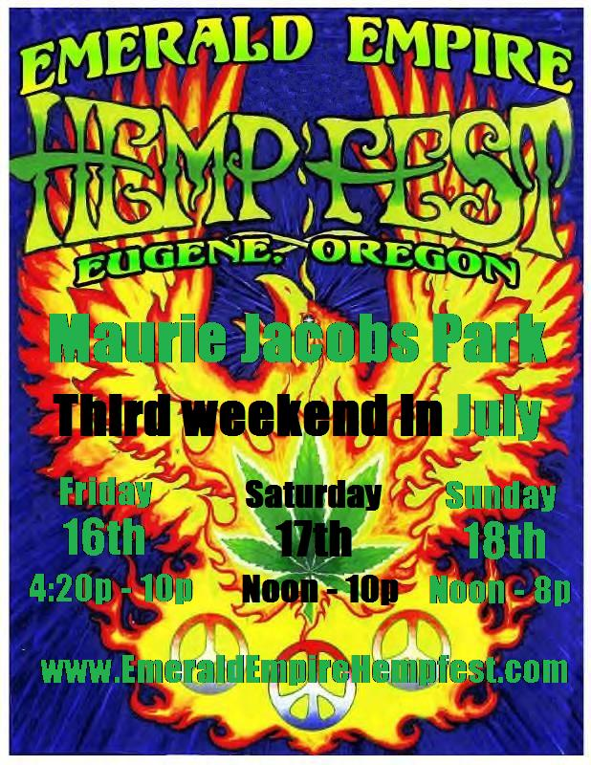

Willamette Valley NORML presents  Emerald Empire Hempfest - 2010  at Maurie Jacobs Park, 301 N Adams St, Eugene, OR, 97402 * July 16, 17 & 18, 2010 - Friday - 4:20p-10:00p, Saturday - High Noon-10:00p, Sunday - High Noon-8:00pm * The Emerald Empire HempFest is an annual event (third weekend in July), held in a city park. This all-volunteer effort is a ‘Free-to-the-public’ event. The Mission: The purpose of the EEH is to inform, educate and activate citizens in calling for sweeping reforms in America's laws against cannabis and hemp, a uniquely valuable plant: it provides high levels of key nutrients, relieves symptoms for patients suffering from an array of medical conditions, and can be made into environmentally positive products such as clothing, paper, paint, biodegradable plastics, and replacements for fossil fuels. Please join us in the fight to roll back prohibition and increase production and usage of one of the world's most beneficial plants. Hope to see you there! With your help, Hempfest 2010 will be even bigger and better. This is an Alcohol-Free, ALL AGES event.  Contact: Dan Koozer, at (541) 517-0957 – or -  www.EmeraldEmpireHempfest.com |  | Willamette Valley NORML presents  Emerald Empire Hempfest - 2010  at Maurie Jacobs Park, 301 N Adams St, Eugene, OR, 97402 * July 16, 17 & 18, 2010 - Friday - 4:20p-10:00p, Saturday - High Noon-10:00p, Sunday - High Noon-8:00pm * The Emerald Empire HempFest is an annual event (third weekend in July), held in a city park. This all-volunteer effort is a ‘Free-to-the-public’ event. The Mission: The purpose of the EEH is to inform, educate and activate citizens in calling for sweeping reforms in America's laws against cannabis and hemp, a uniquely valuable plant: it provides high levels of key nutrients, relieves symptoms for patients suffering from an array of medical conditions, and can be made into environmentally positive products such as clothing, paper, paint, biodegradable plastics, and replacements for fossil fuels. Please join us in the fight to roll back prohibition and increase production and usage of one of the world's most beneficial plants. Hope to see you there! With your help, Hempfest 2010 will be even bigger and better. This is an Alcohol-Free, ALL AGES event.  Contact: Dan Koozer, at (541) 517-0957 – or -  www.EmeraldEmpireHempfest.com
Willamette Valley NORML presents  Emerald Empire Hempfest - 2010  at Maurie Jacobs Park, 301 N Adams St, Eugene, OR, 97402 * July 16, 17 & 18, 2010 - Friday - 4:20p-10:00p, Saturday - High Noon-10:00p, Sunday - High Noon-8:00pm * The Emerald Empire HempFest is an annual event (third weekend in July), held in a city park. This all-volunteer effort is a ‘Free-to-the-public’ event. The Mission: The purpose of the EEH is to inform, educate and activate citizens in calling for sweeping reforms in America's laws against cannabis and hemp, a uniquely valuable plant: it provides high levels of key nutrients, relieves symptoms for patients suffering from an array of medical conditions, and can be made into environmentally positive products such as clothing, paper, paint, biodegradable plastics, and replacements for fossil fuels. Please join us in the fight to roll back prohibition and increase production and usage of one of the world's most beneficial plants. Hope to see you there! With your help, Hempfest 2010 will be even bigger and better. This is an Alcohol-Free, ALL AGES event.  Contact: Dan Koozer, at (541) 517-0957 – or -  www.EmeraldEmpireHempfest.com |  | Willamette Valley NORML presents  Emerald Empire Hempfest - 2010  at Maurie Jacobs Park, 301 N Adams St, Eugene, OR, 97402 * July 16, 17 & 18, 2010 - Friday - 4:20p-10:00p, Saturday - High Noon-10:00p, Sunday - High Noon-8:00pm * The Emerald Empire HempFest is an annual event (third weekend in July), held in a city park. This all-volunteer effort is a ‘Free-to-the-public’ event. The Mission: The purpose of the EEH is to inform, educate and activate citizens in calling for sweeping reforms in America's laws against cannabis and hemp, a uniquely valuable plant: it provides high levels of key nutrients, relieves symptoms for patients suffering from an array of medical conditions, and can be made into environmentally positive products such as clothing, paper, paint, biodegradable plastics, and replacements for fossil fuels. Please join us in the fight to roll back prohibition and increase production and usage of one of the world's most beneficial plants. Hope to see you there! With your help, Hempfest 2010 will be even bigger and better. This is an Alcohol-Free, ALL AGES event.  Contact: Dan Koozer, at (541) 517-0957 – or -  www.EmeraldEmpireHempfest.com

