End the Waste, End the Abuse, End the War! 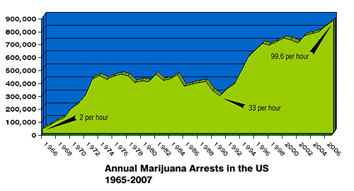
How? Just Act NORML

We - the United States - arrested our 20,000,000th pot-head last year, in 2006 we busted almost 900,000 - soon we'll be popping a million a year. And now there are 35 legislative items in play this session in the Beaver state and it's not done yet.

Willamette Valley NORML of Eugene, Oregon, is reaching out at all levels to let cannabis law reform minded folks as well as the public know about cannabis prohibition’s bid for it's own bail-out in Oregon and the related costs to we the people. In human as well as financial terms.

We will do this in part by surveying the people, both on the street and on-line; posing and posting Q&As - Are you NORML? Why/Why not? "Whats a NORML? Do you want to be NORML? "What does it mean?" What do you think needs to be done?

Along the way we will put "Rights" Cards in everybody’s hands, distribute and play videos - like "Busted" - at every opportunity and do the all-around para-legal networking that will end up maximizing resistance, fostering jury nullification and generally turning victims into civilly disobedient activists.

Further we will engender not just "fishing", but "teaching to fish", and encourage & empower folks to network and organize at a neighborhood level (Heads in the 'Hood). Whenever we get contact from two or more in the same area we get one of them to find a local, public spot that can be advertised for meet-up. Then enable further private meetings and organizing for action. We can help in a number of ways but mostly we empower you folks to act upon your own initiative, especially with the local "ground game". Same with lobbying and watchdogging.

--- WHAT ---

We will be setting up a state-wide meetings and summits. We will be inviting all cannabis law reform minded, open to the public. We will have session for major groups and time for people off the street. We will endeavor to set up side-bars and meeting rooms so individuals and groups can focus on matters by subject or region. (projects > places to conference, getting input for agenda, facilitation resources)
R U NORML?
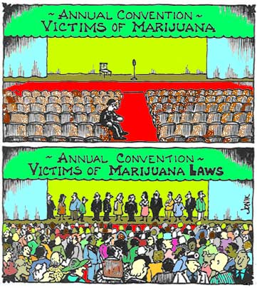
DO U WANNA B?

Displays and other meeting tools along with remote access so people can conference call, videoconference or just observe if they can't make it in person.

We will document the process and resources in an effort to get mini-summits happening across the state on a grassroots basis. We will involve online resources and make it a constant, on-going process that happens over the Internet in between face-to-face gatherings. (see On-line Meetings idea)

We will do this with and thru our Newsletter, TV Shows and other media. Also strive to enable others by publishing and otherwise networking all resources involved, particularly How To with all the little tips, tools and tricks that only experience can provide.

--- HOW ---

To accomplish this we encourage individuals to attempt meet-ups and generally survey their neighborhood or area. To network court and prison support resources as they defend each other. Especially for those using for unqualified medical and spiritual purposes, doubly so in states without any medical law yet. (regional networking, re: Idaho) This also prepares us for going thru the same kind of thing with hemp, should we get so lucky. (see White Plume case)

The kind of Tools and Tool Sheds we will utilize and build for this are -

- Issue database; record the Problems people face in detail, particularly any corresponding Ideas. One end result will be a web page where visitors can look up info by keyword.

- Idea database; to record info about Items, especially where it is a Solution to an Issue.

- Music.Net, Music4NORML, etc; network musicians and related resources to produce an event or song for a show. Also to teach how to make music. One result should be like Band.Net, a web page where Bands go to leave their contact info and activists go to look for Bands. Lists of places to do shows and the parameters at each - costs, capacity, etc. (see alo, Fest.net)

- Art.Net, Art4NORML; Network Art and Artists both currently NORML and to be. Also cross-train in How To Art, etc. The end result/s are web pages serving as on-line galleries as well as art shows off-line to support the artists and raise awareness.

- Library; to store all documentation and literature. Advertisements - to utilize as is and for ideas, Letters-to-the-Editor, How To Do Stuff, Chapter Bylaw examples, Initiative Text, Grant Proposals - and the means to add categories as well as documentation - as well as all related Resources to utilize and learn from.
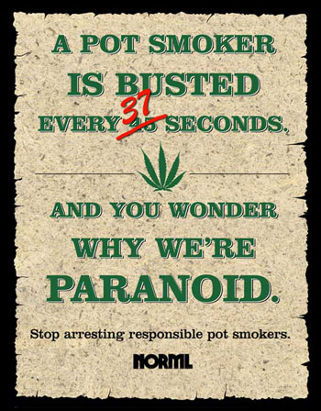

- and continue this trend thru all disciplines, skills and professions.

Your $20 membership supports our activity and gets you priority notice of news, action and events as they happen in the state, across America and around the world. Please fill out the sign-up form and send in today! First, tho, we'd you to make a copy and share this exiting opportunity with someone you know. Because, in addition you get a year of National NORML membership for free. Conversely, if you're already a member of NORML - affiliated or National - we'll give you a year of W-V-NORML membership free. The first of many, we're sure.

Your financial contributions also support these fine projects and action items -

- Eugenes Cannabis TV.
- Emerald Empire Hempfest
- Eugene entry for the Global Marijuana March
- Outreach and Support programs to help those busted and maximize the effort the end the busting.

The bottom line is Cannabis Prohibition wa$tes and kills, much, much more than cannabis itself, and that the killing waste - and related co$ts, including lack of gain from hemp and medicine - will continue as long as We, The People, let it.
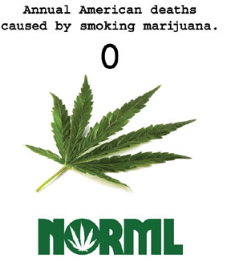

Network with us at what ever level you can; Link your Node or Join Up and BE the Network that Ends Cannabis Prohibition. If you can't afford full membership, please feel free to associate by signing up for email or attending our public meeting every 4th Saturday of the month at - Herbs Toasted Subs, 1210 Willamette St, Eugene, Oregon, 97401

Don’t Delay, Start today! Team with W-V-NORML and Get in on the grassroots effort for cannabis law reform in the Willamette Valley and beyond. Join like-minded individuals in ending the war on hemp and medical cannabis by ending prohibition in general. Contact Willamette Valley NORML at: P.O. Box 10957, Eugene, OR 97440-2957, by visiting >> w-v-norml.org <<-or- calling: 541.517-0957

Truly, They are few, and We are many. Past time we started acting like it.

yours, in the trenches,

DanK, Perry, Jim, Jen, Mike,
and All the Gang at
Willamette Valley NORML – your Cannabis Law Reform activist network

"Prohibition was introduced as a fraud; it has been nursed as a fraud. It is wrapped in the livery of Heaven, but it comes to serve the devil. It comes to regulate by law our appetites and our daily lives. It comes to tear down liberty and build up fanaticism, hypocrisy, and intolerance. It comes to confiscate by legislative decree the property of many of our fellow citizens.

It comes to send spies, detectives, and informers into our homes; to have us arrested and carried before courts and condemned to fines and imprisonments. It comes to dissipate the sunlight of happiness, peace, and prosperity in which we are now living and to fill our land with alienations, estrangements, and bitterness. It comes to bring us evil - only evil - and that continually.

Let us rise in our might as one and overwhelm it with such indignation that we shall never hear of it again as long as grass grows and water runs."

-- Roger Q. Mills of Texas, 1887, quoted repeatedly
during a December 1914 debate in Congress over alcohol Prohibition

