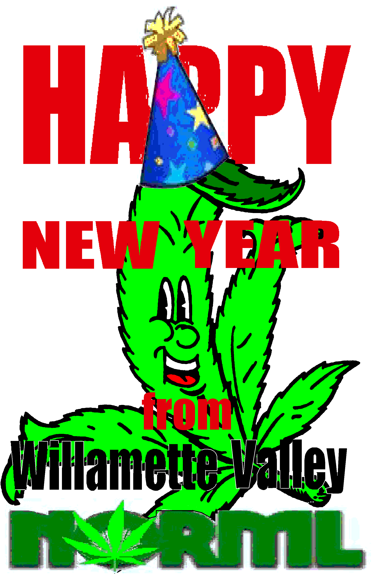

Willamette Valley NORML hosts  Meet The New Year - 2011  Saturday, January 15th * 8:00pm til we’re done! * Meet The New Year party hosted by W-V-NORML at the Voter Power Office in Eugene, at 687 River Ave., Eugene, 97404-2513 * Meet The New Year, Same As The Old Year – Unless YOU Make A Difference (sung to the tune “Won’t Get Fooled Again” by The Who). Join Willamette Valley NORML as we start working on making the year better than the last by laying down a foundation for real change. There will be Raffles for stuff, Music, Food and Fun, of course, but also: Info on Avoiding Busts and What to do in a Law Enforcement Encounter; How to Get Your Card, Volunteer for The Cause, or otherwise Help Out, and more! $5 donation at the door. For more info Contact: Willamette Valley NORML, at (541) 517-0957 – or - w-v-norml.org |  | Willamette Valley NORML hosts  Meet The New Year - 2011  Saturday, January 15th * 8:00pm til we’re done! * Meet The New Year party hosted by W-V-NORML at the Voter Power Office in Eugene, at 687 River Ave., Eugene, 97404-2513 * Meet The New Year, Same As The Old Year – Unless YOU Make A Difference (sung to the tune “Won’t Get Fooled Again” by The Who). Join Willamette Valley NORML as we start working on making the year better than the last by laying down a foundation for real change. There will be Raffles for stuff, Music, Food and Fun, of course, but also: Info on Avoiding Busts and What to do in a Law Enforcement Encounter; How to Get Your Card, Volunteer for The Cause, or otherwise Help Out, and more! $5 donation at the door. For more info Contact: Willamette Valley NORML, at (541) 517-0957 – or - w-v-norml.org
Willamette Valley NORML hosts  Meet The New Year - 2011  Saturday, January 15th * 8:00pm til we’re done! * Meet The New Year party hosted by W-V-NORML at the Voter Power Office in Eugene, at 687 River Ave., Eugene, 97404-2513 * Meet The New Year, Same As The Old Year – Unless YOU Make A Difference (sung to the tune “Won’t Get Fooled Again” by The Who). Join Willamette Valley NORML as we start working on making the year better than the last by laying down a foundation for real change. There will be Raffles for stuff, Music, Food and Fun, of course, but also: Info on Avoiding Busts and What to do in a Law Enforcement Encounter; How to Get Your Card, Volunteer for The Cause, or otherwise Help Out, and more! $5 donation at the door. For more info Contact: Willamette Valley NORML, at (541) 517-0957 – or - w-v-norml.org |  | Willamette Valley NORML hosts  Meet The New Year - 2011  Saturday, January 15th * 8:00pm til we’re done! * Meet The New Year party hosted by W-V-NORML at the Voter Power Office in Eugene, at 687 River Ave., Eugene, 97404-2513 * Meet The New Year, Same As The Old Year – Unless YOU Make A Difference (sung to the tune “Won’t Get Fooled Again” by The Who). Join Willamette Valley NORML as we start working on making the year better than the last by laying down a foundation for real change. There will be Raffles for stuff, Music, Food and Fun, of course, but also: Info on Avoiding Busts and What to do in a Law Enforcement Encounter; How to Get Your Card, Volunteer for The Cause, or otherwise Help Out, and more! $5 donation at the door. For more info Contact: Willamette Valley NORML, at (541) 517-0957 – or - w-v-norml.org

